Frontend Development with React.js Project Documentation for Insight Stream

- Introduction
  - Project Title : Insight Stream : Navigate the News Landscape
  - Team Members:
Jeeva M(Team Leader) [Email Id: jeevavenkatesh133@gmail.com ]
Aslin Benish NS [Email Id: aslinbenish225@gmail.com ]
Gokul G [Email Id: gokulganapathi645@gmail.com ]
Dass Prakash S [Email Id: dassprakash220@gmail.com
Hariharan M [Email Id: hariharanmurugan133@gmail.com ]

Project Overview
  - Purpose:
InsightStream is a web application designed to enhance how users discover and consume news. It offers an intuitive interface, dynamic search, and diverse news categories, ensuring a seamless and personalized news experience..

Features:
    - News Aggregation: Fetches real-time news from multiple API sources.
    - Visual News Exploration: Enhances engagement with curated image galleries.
    - Trending & Category-Based News: Offers easy navigation through various news sections.
    - User-Friendly Interface: Built with React.js for a smooth, responsive experience.
    - Newsletter Subscription: Keeps users updated with personalized news..

Architecture
  - Component Structure:
The application is built using React.js with a component-based architecture. Major components include:

    - Components/ – Reusable UI elements (Navbar, Hero, NewsCard, Footer).
    - Pages/ – Main views (Home, Categories, SearchResults, ArticlePage).
    - Context/ – State management (NewsContext for global news data).
    - Styles/ – CSS/Tailwind styles for UI consistency..

State Management:
- Uses React Context API for managing global state (e.g., news articles, user preferences).
- NewsContext stores fetched news data and provides it to components.
- useState for local UI state management (e.g., search input, loading states).

Routing:
The application uses React Router for navigation. Routes include:
    - Home (/) – Displays trending news & categories.
    - Category (/category/:name) – Shows news by category.
    - Search (/search?q=query) – Displays search results.
    - Article (/article/:id) – Redirects to the full news article.

Setup Instructions
  - Prerequisites:
    - Node.js (v16 or higher)
    - npm (v8 or higher)
    - Git

Installation:
- Clone the repository git clone <repository-url>cd news-app-react
- Navigate to the client directory:
- Install dependencies: npm install
- Configure environment variables: Create a .env file in the client directory and add the necessary variables (e.g., API keys).
- Start the development server: npm start

Folder Structure
  - Client:

components/ – Reusable UI elements (Navbar, Hero, NewsCard)

pages/ – Main views (Home, Categories, SearchResults, ArticlePage).

context/ – Manages global state via React Context API.

styles/ – Stores global CSS/Tailwind styles.

App.js & index.js – Core React files.

public/ – Static assets (favicon, manifest).

package.json & README.md – Dependencies & documentation.

Utilities:
    - api/ – Handles API requests (news fetching via Axios).
    - helpers/ – Utility functions (formatting, filtering).
    - constants/ – Static values (API keys, categories)..

Running the Application Frontend:
- To start the frontend server, run the following command in the client directory: npm start
- npm install
- npm start
- The application will be available at http://localhost:3000

Component Documentation
  - Key Components:
- Navbar.js – Top navigation with search.
- Hero.js – Displays trending news.
- Home.js – Main page with latest news.
- CategoryPage.js – Lists news by category.

- SearchResults.js – Shows search results.
- ArticlePage.js – Displays full news article.
- Footer.js – Bottom section with links.

State Management

NewsCard.js – Displays a single news item.

Button.js – Custom button component.

LoadingSpinner.js – Shows while fetching data.

SearchBar.js – Input for news search.

CategoryList.js – Renders category links.

NewsletterSignup.js – Subscription form

User Interface
  - Screenshots
    - Home Page: Display featured tracks and recommended playlists.

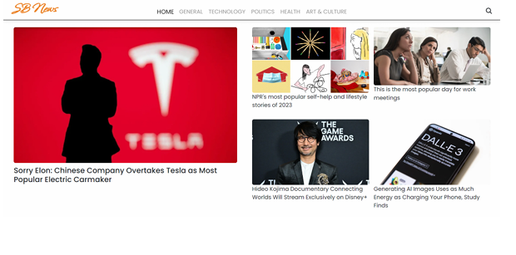

    - Search Page: Allows users to search for News,art & culture etc..

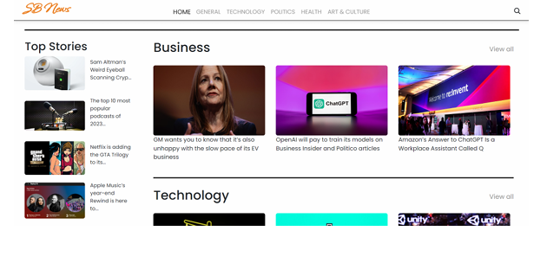

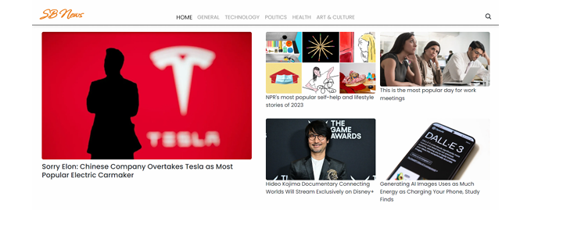

Styling
  - CSS Frameworks/Libraries:
The application uses Styled-Components for styling. This allows for modular and scoped CSS within components.

Theming:
A custom theme is implemented using Styled-Components, with support for light and dark modes.

Testing
  - Testing Strategy:
    - Unit Testing: Using Jest and React Testing Library.
    - Integration Testing: Is performed to ensure that components work together as expected.
    - End-to-End Testing: Cypress is used for end-to-end testing of user flows.

Code Coverage:
    - Code coverage is monitored using Jest’s built in coverage tool. The current coverage is 85%.

Screenshots or Demo
  - Demo Link: https://drive.google.com/file/d/1c7DZYlLN-ci3YEWyx89lE77gNS_iL4CH/view?usp=drivesdk

  - Screenshots: See section 9 for UI screenshots.

Known Issues
- Issue 1: API Rate Limits – Excessive requests may trigger restrictions, causing data fetch failures.
  - Issue 2: Slow Loading – Fetching large news datasets can impact performance and user experience..

Future Enhancements
  - Future Features:
    - User Authentication – Save articles and personalize news.
    - Dark Mode – Toggle for better readability.
    - Push Notifications – Get breaking news alerts.
    - Offline Mode – Access saved articles without the internet.
    - Multi-Language Support – Read news in various languages..

This documentation provides a comprehensive overview of the InsightStream : News project, including its architecture, setup instructions, and future plans.

